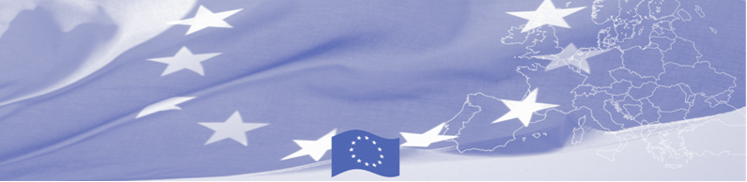
PRESS RELEASE

September 20, 2016

Border guards and customs officers of Central Asia are trained on border check ethics and public service standards

A total of 20 border guards and customs officers from five Central Asian countries (Kazakhstan, Kyrgyzstan, Tajikistan, Turkmenistan and Uzbekistan) are being trained to use modern technics and international standards in border checks. The workshop, which takes place on 20-22 September in Almaty, is organised by the EU-funded Border Management in Central Asia Programme (BOMCA), and facilitated by the experts from Latvia.
This BOMCA activity aims at strengthening the capacity of border control officers in identification and profiling mechanisms, which helps to better categorise different types of persons, crossing the borders in respecting document security, ethics and human rights.
During the workshop participants will gain knowledge about the EU standards in provision of appropriate basic services to the most vulnerable groups of migrants crossing the border - irregular migrants, refugees, victims of trafficking, minors and elderly persons. This includes due identification of these groups of migrants and conducting needs assessment to define his/her needs, providing services or referring to service provider, as well as establishing cooperation mechanisms for the effective migrant referral.. A separate session will be dedicated to the border checks ethics and public services standards, which includes sensitivity to gender, ethnicity, protecting migrant’s data and respecting migrant’s rights and dignity.

First BOMCA operations began in Central Asia in 2003, and since then, BOMCA has strengthened partnership of the Central Asia Governments in the field of border management. The European Union allocated a sum of EUR 33.6 million to BOMCA for the period of 2003 – 2014 and almost EUR 5 million for its 9th implementation phase (2015 - 2018).

For more information please contact Mr Amir Yelchibekov, BOMCA National Coordinator for Kazakhstan, tel: +7 (701) 532 02 64, e-mail: amir.yelchibekov@icmpd.org or Ms Yerkezhan Amriyeva, Press and Information Assistant, EU Delegation to Kazakhstan, e-mail: yerkezhan.amriyeva@ext.eeas.europa.eu

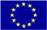  The Programme is imple-mented by the Consortium of partners led by the State Border Guard of the Republic of Latvia:  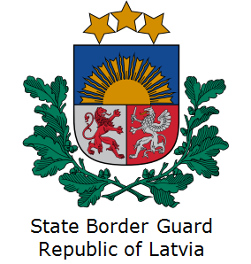 | This Programme is funded by the European Union  Delegation of the European Union to Kazakhstan  62, Kosmonavtov street, 4th floor  Astana, 010000, Republic of Kazakhstan  Telephone: + 7 7172 97 45 40,  Fax: + 7 7172 97 45 41  E-mail: Delegation-Kazakhstan@eeas.europa.eu  Website:http://eeas.europa.eu/delegations/Kazakhstan  Website: https://www.bomca-eu.org | The European Union is made up of 28 Member States who have decided to gradually link together their know-how, resources and destinies. Together, during a period of enlargement of 60 years, they have built a zone of stability, democracy and sustainable development whilst maintaining cultural diversity, tolerance and individual freedoms. The European Union is committed to sharing its achievements and its values with countries and peoples beyond its borders

