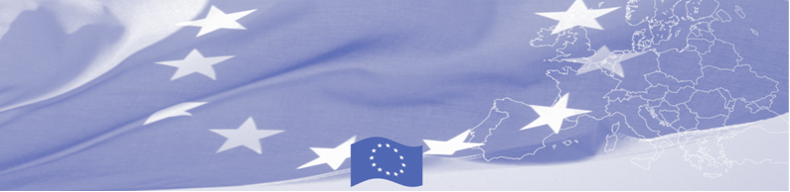
PRESS RELEASE

September 6, 2016

BOMCA experts and Border Representatives discuss cooperation between border communities in Central Asia

On September 06 Technical Assistance Mission of Border Management Programme in Central Asia (BOMCA), funded by the European Union visits Bishkek with the mission to support strengthening of the Local Border Traffic Regimes in Kyrgyzstan, in particular, cooperation between local border communities, local authorities and law enforcement agencies at the borders. The mission will be conducted by the Latvian State Border Guard officials and Border Representatives of Latvia at the state border with Russian Federation and Belarus, Colonel Janis Kononovs and Lieutenant-Colonel Valdis Jukss.

The main goal of this BOMCA activity is to contribute to modernisation of Local Border Traffic Regimes in Central Asia, adapting appropriate EU examples and promoting codification and practical implementation, including cooperation between local border communities, local authorities and law enforcement agencies at the borders of Central Asia.

During the meetings and discussions with the State Border Service officers and Border Representatives of Kyrgyzstan, the expert team will present leading practices of the EU MSs in the area mentioned and together with national partners assess the ways of its adoption in the Kyrgyz Republic. Experts will present in details a comprehensive mechanism of local border traffic, which can simplify cross border movement. The involvement of the Border Representatives to support local border traffic regime functionality will be stressed and need of cooperation between Border Representatives will be promoted.

Based on the Mission’s findings, experts will prepare recommendations for further development of local border traffic regime and cooperation between Border Representatives of Kyrgyzstan and neighbouring countries.

First BOMCA operations began in Central Asia in 2003, and since then, BOMCA has strengthened partnership of the Central Asia Governments in the field of border management. The European Union allocated a sum of EUR 33.6 million to BOMCA for the period of 2003 – 2014 and almost EUR 5 million for its 9th implementation phase (2015 - 2018).

For more information, please visit web-site www.bomca-eu.org or contact Ms. Janna Tashieva, BOMCA National Coordinator for Kyrgyzstan – janna.tashieva@icmpd.org
  The Programme is implemented by the Consortium of partners led by the State Border Guard of the Republic of Latvia:  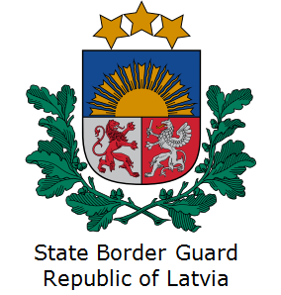 | This Programme is funded by the European Union  Delegation of the European Union to the Kyrgyz Republic  21 Erkindik Boulevard, Business Centre Orion, 5th floor  Bishkek, 720040, Kyrgyz Republic  Telephone: +996 312 26 10 00  Fax: +996 312 26 10 07  E-mail: delegation-kyrgyzstan@eeas.europa.eu  Website:http://eeas.europa.eu/delegations/kyrgyzstan  Facebook: http://www.facebook.com/eudelkg | The European Union is made up of 28 Member States who have decided to gradually link together their know-how, resources and destinies. Together, during a period of enlargement of 60 years, they have built a zone of stability, democracy and sustainable development whilst maintaining cultural diversity, tolerance and individual freedoms. The European Union is committed to sharing its achievements and its values with countries and peoples beyond its borders.

