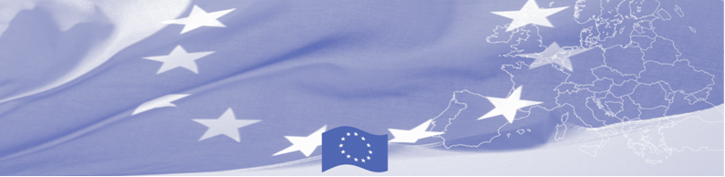
PRESS RELEASE

For release on July 14, 2016

International Donors’ Coordination Meeting on Border Management and Trade Facilitation takes place in Tashkent.

Following the experience of the previous phases of BOMCA Programme, in particular in enhancing of international donor coordination and cooperation, BOMCA is hosting the International Donors’ Coordination meeting, which takes place in Tashkent on July 14. The meeting is attended by the International Donors’ Community and the Embassies accredited in Uzbekistan (EU Delegation to Uzbekistan, Embassy of the Republic of Latvia, JICA, UNODC, USAID and others).

The overall objective of the event is to encourage international donor coordination and greater coherence among the donor actions, in particular in the field of border management and trade facilitation. It will provide an opportunity to share information on the ongoing or foreseen donor projects in Uzbekistan, to discuss different approaches, gaps, best practices and lessons learnt from the implementation of programmes and activities. The range, scale and focus of donor investment in Uzbekistan will be captured, essential achievements will be presented and opportunities for further donor cooperation at country level will be identified.

First BOMCA operations began in Central Asia in 2003, and since then, BOMCA has strengthened partnership of the Central Asia Governments in the field of border management. The European Union allocated a sum of EUR 33.6 million to BOMCA for the period of 2003 – 2014 and almost EUR 5 million for its 9th implementation phase (2015 - 2018). The overall objective of the current phase of the Programme, which is to increase effectiveness and efficiency of border management in Central Asia, will be reached by introducing advanced elements of the Integrated Border Management (IBM), assisting governments in developing and reforming their migration governance, mobility and trade facilitation policies and strengthening capacities of Border and Migration Agencies.

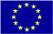  The Programme is imple-mented by the Consortium of partners led by the State Border Guard of the Republic of Latvia:  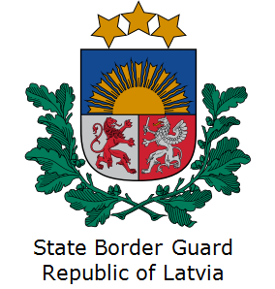 | This Programme is funded by the European Union  Delegation of the European Union to the Republic of Uzbekistan  International Business Centre,  107 B Amir Temur Street  100 084 Tashkent, Uzbekistan  Telephone: +998 71 120 16 01/02/03/04  Fax: +998 71 120 16 08  E-mail: delegation-uzbekistan@eeas.europa.eu  Website: http://www.eeas.europa.eu/delegations/uzbekistan | The European Union is made up of 28 Member States who have decided to gradually link together their know-how, resources and destinies. Together, during a period of enlargement of 60 years, they have built a zone of stability, democracy and sustainable development whilst maintaining cultural diversity, tolerance and individual freedoms. The European Union is committed to sharing its achievements and its values with countries and peoples beyond its borders.

