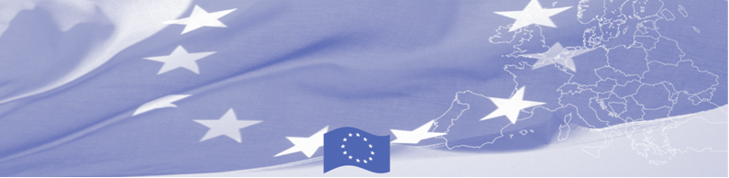
PRESS RELEASE

BOMCA holds first National Steering Group meeting in Tashkent
For release on 13 July 2016

On July 13, BOMCA Programme hosted the National Steering Group meeting in Uzbekistan, which gathered main BOMCA national counterparts – Ministry of Foreign Affairs, National Coordinating Unit of the European Union’s Technical Assistance Programme under the Cabinet of Ministers, State Border Guards Committee under the National Security Services, State Customs Committee, Ministry of Agriculture and Water Resource, as well as representatives of the EU and BOMCA programme consortium.
The purpose of the NSG meeting was to discuss the implementation aspects of BOMCA Programme, such as progress achieved, lessons learnt, and modalities of the future activities. The meeting was important not only in terms of discussing plans for the rest of the year, but also laid a foundation for further cooperation and established a forum for presentation of achievements, evaluation of results and valuable feedback from national partners.
In the first half of 2016, over 35 Uzbek beneficiaries took an active part in 6 national and regional activities, organized by BOMCA. Such strong commitment from Uzbek side is expected also in 12 upcoming activities that are planned for the rest of the year.
National Steering Groups (NSG), consisting of the representatives of the main national beneficiary agencies, has been established in each of 5 Central Asian countries. These meetings are held on a regular basis and present an important coordination mechanism for implementation of the programme at the national level.
First BOMCA operations began in Central Asia in 2003, and since then, BOMCA has strengthened partnership of the Central Asia Governments in the field of border management. The European Union allocated a sum of EUR 33.6 million to BOMCA for the period of 2003 – 2014 and almost EUR 5 million for its 9th implementation phase (2015 - 2018). The overall objective of the current phase of the Programme, which is to increase effectiveness and efficiency of border management in Central Asia, will be reached by introducing advanced elements of the Integrated Border Management (IBM), assisting governments in developing and reforming their migration governance, mobility and trade facilitation policies and strengthening capacities of Border and Migration Agencies.

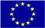  The Programme is implemented by the Consortium of partners led by the State Border Guard of the Republic of Latvia:  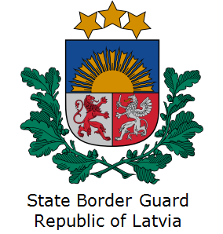 | This Programme is funded by the European Union  Delegation of the European Union to the Republic of Uzbekistan  International Business Centre,  107 B Amir Temur Street  100 084 Tashkent, Uzbekistan  Telephone: +998 71 120 16 01/02/03/04  Fax: +998 71 120 16 08  E-mail: delegation-uzbekistan@eeas.europa.eu  Website: http://www.eeas.europa.eu/delegations/uzbekistan | The European Union is made up of 28 Member States who have decided to gradually link together their know-how, resources and destinies. Together, during a period of enlargement of 60 years, they have built a zone of stability, democracy and sustainable development whilst maintaining cultural diversity, tolerance and individual freedoms. The European Union is committed to sharing its achievements and its values with countries and peoples beyond its borders.

