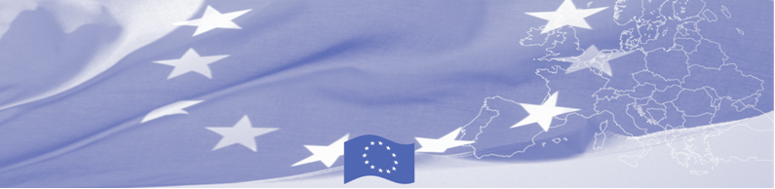
PRESS RELEASE

For release on March 29, 2016, at 9.00 AM

Joint meeting of international donors and national agencies takes place in Astana

Following the experience of the previous phases of BOMCA Programme, in particular in enhancing international donor coordination and cooperation and strengthening stakeholder networking, BOMCA in close cooperation and partnership with CADAP, OSCE and US Embassy is hosting the International Donors Coordination Meeting, which takes place in Astana on March 29. The meeting is gathering national beneficiaries such as the State Committee of National Security, Border Service, Ministry of Finance, Ministry of Interior, Ministry of Public Health and Social Development, Ministry of Education and Science, General Prosecutor’s office and Ministry of Foreign Affairs as well as international donors and agencies (EU Delegation to Kazakhstan, IOM, CADAP, UNODC and others).

The overall objective of the event is to encourage international donor coordination and interaction among partners and stakeholders and greater coherence among the donor actions, in particular in the field of border security and counter-narcotics issues. It will provide an opportunity to share information on the ongoing or planned donor projects in Kazakhstan, to define priorities together with Government counterparts and to discuss different approaches, gaps, best practices and lessons learnt from the implementation of programmes and activities. The range, scale and focus of donor investment in Kazakhstan will be captured, essential achievements will be presented and opportunities for further donor cooperation at country level will be identified and explored.

First BOMCA operations began in Central Asia in 2003, and since then, BOMCA has strengthened partnership of the Central Asia Governments in the field of border management. The European Union allocated a sum of EUR 33.6 million to BOMCA for the period of 2003 – 2014 and almost EUR 5 million for its 9th implementation phase (2015 - 2018).

For more information please contact Mr. Amir Yelchibekov, BOMCA National Coordinator in Kazakhstan – (+7 701) 532 02 64 or amir.yelchibekov@icmpd.org

  The Programme is imple-mented by the Consortium of partners led by the State Border Guard of the Republic of Latvia:  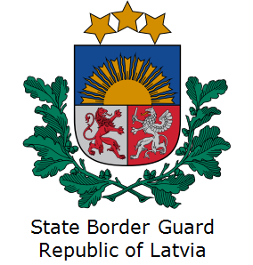 | This Programme is funded by the European Union  Delegation of the European Union to Kazakhstan  62, Kosmonavtov street, 4th floor  Astana, 010000, Republic of Kazakhstan  Telephone: + 7 7172 97 10 40, 97-11-48  Fax: + 7 7172 97 95 63  E-mail: Delegation-Kazakhstan@eeas.europa.eu  Website:http://eeas.europa.eu/delegations/Kazakhstan  Website: https://www.bomca-eu.org | The European Union is made up of 28 Member States who have decided to gradually link together their know-how, resources and destinies. Together, during a period of enlargement of 60 years, they have built a zone of stability, democracy and sustainable development whilst maintaining cultural diversity, tolerance and individual freedoms. The European Union is committed to sharing its achievements and its values with countries and peoples beyond its borders.

