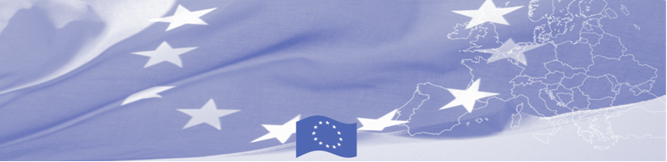
PRESS RELEASE

BOMCA carries out Technical Assistance Mission in Ashgabat
24 February 2016

On February 24-26 in the framework of the technical assistance mission of the BOMCA Programme, the EU MS expert will visit Ashgabat and meet with the representatives of the border guards, customs services and phytosanitary agencies.

The aim of this mission is to contribute to the institutional development of agencies involved in border control. During the mission the expert, Mr. Mashkovs, Deputy Director of Customs Service of Latvia, will have a series of meetings with the representatives of the State Border Guards Service and State Customs Service of Turkmenistan, the State Service on Plant Quarantine and the State Service of Veterinary Control of the Ministry of Agriculture of Turkmenistan and the Sanitary-epidemiology Service of the Ministry of Health and Medical Industry of Turkmenistan to discuss current procedures at the border for the transportation means and vehicles, present EU practices in this regard and jointly map areas for advancing inter-agency cooperation in performing the joint control of means of transportation. Upon the end of the activity, the recommendations will be finalised by the expert and shared with the national authorities.

The overall objective of current phase of BOMCA Programme is to increase effectiveness and efficiency of border management in Central Asia by introducing advanced elements of the Integrated Border Management (IBM), assisting governments in developing and reforming their migration governance, mobility and trade facilitation policies and strengthening capacities of Border and Migration Agencies. First BOMCA operations began in Central Asia in 2003, and since then, BOMCA has strengthened partnership of the Central Asia Governments in the field of border management. The European Union allocated a sum of EUR 33.6 million to BOMCA for the period of 2003 – 2014 and almost EUR 5 million for its 9th implementation phase (2015 - 2018).

For more information, please contact Ms. Aygul Saparova, BOMCA National Coordinator for Turkmenistan: +993363282074 or aygul.saparova.bomca@gmail.com

  The Programme is implemented by the Consortium of partners led by the State Border Guard of the Republic of Latvia:  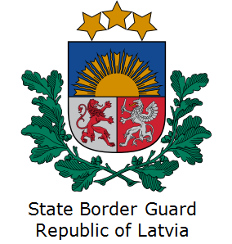 | This Programme is funded by the European Union  Delegation of the European Union to the Republic of Turkmenistan  Pervy Proezd Myati Kosaeva, 8, Ashgabat. Tel: +993-12-349752  E-mail: delegation-turkmenistan@eeas.europa.eu | The European Union is made up of 28 Member States who have decided to gradually link together their know-how, resources and destinies. Together, during a period of enlargement of 60 years, they have built a zone of stability, democracy and sustainable development whilst maintaining cultural diversity, tolerance and individual freedoms. The European Union is committed to sharing its achievements and its values with countries and peoples beyond its borders.

